**Leader Overview**

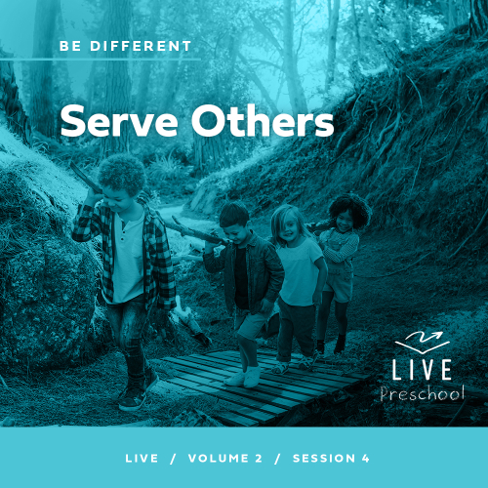

**Volume Overview**

**Be Different**

*Christians have long understood that we live and walk a fine line. We are to be in the world—all things to all people, as Paul put it—yet not of the world. God’s people have always been a chosen people, holy and set apart from the world’s ways. To pull it off, to be truly different, means we must each hold fast to the truth, speaking it when needed, all while humbling ourself and faithfully serving others.*

**Session Overview**

**Serve Others**

*In this* **Live** *session, preschoolers will explore the truth that Jesus is the King of kings. Instead of coming to the earth to wear a crown, He came to serve. When His disciples wanted to sit next to Him in heaven, Jesus reminded them that they should help others instead. Kids will discover that they can follow Jesus’ teaching and choose to help others.*

**Bible Lesson**

James and John Get a Lesson on Greatness

[Matthew 20:20–28](https://ref.ly/logosref/Bible.Mt20.20-28)

**Faith Fact**

I will help others.

**Faith Verse**

[Romans 12:2](https://ref.ly/logosref/Bible.Ro12.2) (NLT)

Don’t copy the behavior and customs of this world, but let God transform you into a new person by changing the way you think.

**Preparing for the Session**

**Leader Preparation Time: 20–25 Minutes**

|  |
| --- |
| ***You Will Need***  ***Preservice Activities***  *• Tennis ball (or other small ball)*  *• Stickers or small prizes, one or more per kid*  *• Leader’s choice of snack*  *• Toys*  ***Large Group***  *• Bible*  *• Worship songs (Song suggestions: “Boom” by GO Kids; “For All My Days” by Gateway Kids Lyric Video; “Jump” by River Valley GO Kids Music)*  *• For groups not using a phone or tablet only, add:*  *• Projector or TV*  *• Laptop*  *•* ***Faith Fact Sound*** *video (bell ringing)*  *•* ***Faith Fact Slide***  ***• Faith Verse Slide***  *•* ***Faith Verse Video***  *•* ***Bible Lesson Video A***  *•* ***Bible Lesson Video B***  ***Small Group***  *•* ***Small Group Activity Page****, one per kid*  *• Pencils or pens, one per kid*  *• Crayons or markers*  *• Optional: Small prize to send home*  *•* ***Hands-On Learning Page****, one for every four kids*  *• Quart or gallon zipper bags, one per kid*  *• Miniature bottle of water, one per kid*  *• Tissue or tissue pack, one per kid*  *• Bandages, one per kid*  *• Red crayons or markers, one per kid*  *• Scissors*  *To access session content and videos from a computer, visit:* [***BibleEngagementProject.com/downloads***](https://bibleengagementproject.com/downloads) |
| ***Getting Ready***  ***Preservice Activities***  *• Set out toys and snacks.*  ***Large Group***  *• Download videos and slides if needed.*  *• Select worship song(s) and have them ready to play.*  ***Small Group***  *• Print copies of the* ***Small Group Activity Page****, one per kid.*  *• Print copies of the* ***Small Group Hands-on Learning****, one page per four kids.*  *• Cut apart the cards from the* ***Hands-On Learning Page****.*  ***First time leading* Live *for Preschool? Check out the*** [**Facilitator Guide**](https://0b769b0ed3569ef9d18b-f88d8272f61086866d50d048b43ef630.ssl.cf2.rackcdn.com/sites/biblengagementproject/Listen_Facilitator_Guide.pdf)**.** |

**Preservice Activities**

*See what’s needed at the beginning of the session.*

**Bible Story Warm-Up**

Does anyone know what this is? *(Hold up tennis ball.)* Yes. It’s a ball. You can use it to play games and sports. Today, we’ll use it to play a game.

• *Have kids sit in a circle.*

We’ll pass the ball around the circle. As we pass it, we’ll count to seven. Every time we get to seven, the person with the ball will be safe. If you’re safe, you will put your hands on your head. Then, the next time the ball comes around, it will skip you because you’re in a safe spot.

• *Pass ball around until two of the kids are safe.*

Great playing! *(Say to safe kids.)* Because you’re safe, you’re in a special spot. I’ve got a prize that’s just for you. No one else will get one. How does that sound? *(Allow responses.)*

• *Start to hand a prize to the two kids and then stop.*

Wait! You have a choice to make. You can keep the prize for yourself, or you can help everyone. If you want to help others, you can give up your safe spot and not play for the next round. If you do that, everyone will get a prize. If you keep your safe seat, only you will get a prize. What do you want to do?

• *Allow the two kids who are safe to decide what they want to do.*

• *Hand out prizes according to their choice.*

How did it feel when I said you wouldn’t get a prize if you weren’t in the safe spot?

If you were safe, how did it feel to know you were getting something special?

Was it an easy or hard choice to help everyone get a special prize like yours?

• *Play again if you have time. If kids gave up their spot so everyone could get a prize, have them sit out one round.*

Today, we’ll learn about some of Jesus’ friends who wanted to sit in a very special seat next to Him. Jesus told them how they should choose to help others instead just like some of you got to do today.

**Snack**

**Leader’s Choice**

• *Have everyone stand up before serving the snack.*

• *Put a snack at each place at the table.*

Let’s do something a little different today. One at a time, you’ll choose where you want to sit at the table for our snack. Then, before you sit down, I want you to ask me if you can sit in that seat.

• *Call on kids to choose a seat.*

• *When everyone is seated, let the kids eat the snack.*

Our Bible story today is about two of Jesus’ disciples. Their mom asked Jesus if they could sit in special seats right next to Jesus. Would you like to sit next to Jesus? *(Group response)* Me too! Well, all of Jesus’ other disciples wanted to sit next to Jesus. We’ll find out what Jesus said to all of them in our Bible story today. I can’t wait to learn with you.

**Free Play**

*Any extra time can be spent playing with toys.*

**Transition**

*A few minutes before service begins have kids make their way to the large group area and sit in their designated areas.*

**Large Group**

**25 Minutes**

*See what’s needed at the beginning of the session.*

**Introduction**

Hi, everyone! I’m so excited to be here with you! Today, we’ll explore an awesome Bible story. *(Hold up the Bible)*. Of course, we’ll have some fun along the way! If you’re excited to get started, say, “Let’s go!” *(Group response)*

Our story today is about Jesus and His disciples. Guess what? Sometimes, His disciples got mad at each other. Two of Jesus’ disciples wanted to get the best seats next to Jesus for themselves, but the other disciples didn’t like that. Do you think Jesus wanted them to be mad at each other? *(Group response)* No, He didn’t. He talked to them about how they should treat others.

**Faith Fact**

Jesus told everyone they should help others instead. That’s what our Faith Fact is about. **I will help others.**

• *Show the* ***Faith Fact Slide.***

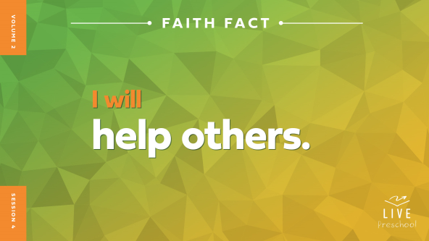

Let’s say our Faith Fact together. **I will help others.** This time let’s shout the word *others* when we say it. **I will help others**. Great! Now lean in close and whisper the Faith Fact like we’re telling a friend a secret. **I will help others**. That was awesome!

**Bible Time**

One of the most important things we do when we’re here is learn more about God’s Word. If you love exploring Bible stories with Lizzy and Grandpa, give me a thumbs up. *(Group response)* Let’s see what they’ve been doing.

• *Play* ***Bible Lesson Video A.***

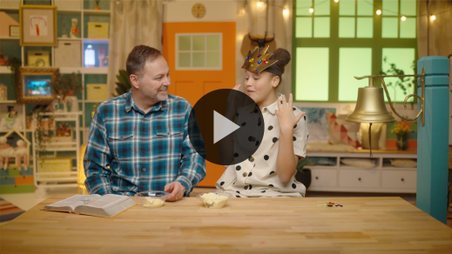

We need some time to think about that, don’t we? Let’s worship Jesus now. Then, we’ll choose what we think is going to happen next in our Bible story.

**Worship**

One way we show Jesus how much we love Him is by learning His truths from the Bible. We also want to tell Jesus how much we love Him through praise and worship. Let’s praise Him for how amazing He is.

**Praise**

Are you glad Jesus came to earth to show us how to live? Spin around one time. *(Group response)*

Who wants to use your hands to help others? Wave your hands up high. *(Group response)*

Who wants to thank Jesus for His love? Stretch your arms as wide as they can go. *(Group response)*

**Sing**

Let’s tell Jesus how much we love Him through singing.

• *Lead the kids in singing one or two songs. See song suggestions at the beginning of the session.*

**Prayer**

Jesus loves every one of us so much. He cares about everything we do, and He promises to help us. Let’s pray.

|  |
| --- |
| *Dear Jesus, thank You for teaching us and helping us every day. You show us Your love in so many ways. You are so good to us, and we want to grow closer to You every day. Amen.* |

**Bible Time cont’d**

Grandpa and Lizzy will be back soon! Let’s think about what might happen next. Can you put on your thinking caps? *(Demonstrate.)* What do you think? Did Jesus tell them to try to get the best seat and a crown for themselves? *(Point to the “crown” graphic.)* Or did He tell them to help others by serving them? *(Point to the “apron” graphic.)*

If you think Jesus told the disciples to try to get the best seat next to Him, pretend to put a crown on your head. If you think Jesus told the disciples to help others, pretend to tie on an apron. Ready? Choose your answer.

• *Pause while kids respond.*

Let’s see if you’re right and check back in with Lizzy and Grandpa.

• *Play* ***Bible Lesson Video B.***

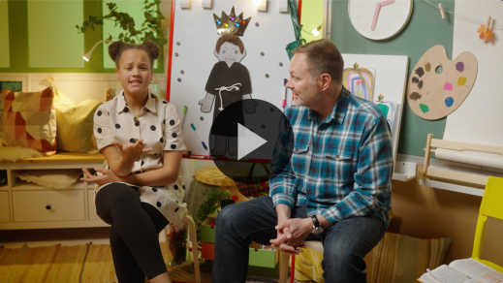

Lizzy and Grandpa showed us how good it feels to help others and to serve Jesus. When I’m worried about getting the best things for myself, I don’t feel happy inside. My face looks a little angry like this. *(Demonstrate face.)* When I help others, Jesus fills my heart with happiness.

**Response Time**

*Play a worship song quietly.*

Let’s respond to what we heard today. Jesus wants to use you to help others. Who can you help this week, and how can you help them?

• *If time allows, let each kid answer the question.*

What great ideas! Let’s pray together and ask Jesus to help others.

• *Have the kids repeat phrases of the prayer after you.*

|  |
| --- |
| *Dear Jesus, thank You for teaching us about helping others. Please give us eyes to see when someone needs help. Give us hands and a heart that want to help them. We pray that the people we help will feel Your love. Amen*. |

**Faith Verse**

I love learning Bible verses with you. You’ve done a great job learning this one so far. Let’s practice our Faith Verse and the actions with Lizzy.

[Romans 12:2](https://ref.ly/logosref/Bible.Ro12.2) (NLT)

Don’t copy the behavior and customs of this world, but let God transform you into a new person by changing the way you think.

• *Show the* ***Faith Verse Video****.*

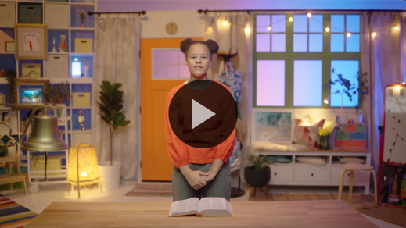

What a great reminder that God doesn’t want us to act like everyone else. He will help us care more about others. We don’t have to do it on our own. When Jesus tells us to help someone, He always promises to help us.

**Closing**

It’s almost time for our small groups. Did you learn more about who Jesus is and how He wants us to live? *(Group response)* Great! We’ve worshipped Jesus by singing. We talked to Him by praying. We’ve practice our Faith Verse. I think I’m missing something. Do you know what it is? *(Allow responses.)*

• *Play the* ***Faith Fact Sound*** *video (bell ringing).*

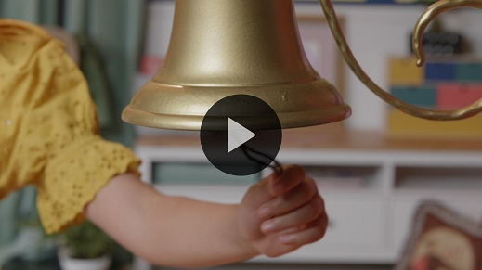

Oh, yes! Our Faith Fact. That sound reminded me to practice our Faith Fact one more time. **I will help others.**

• *Show the* ***Faith Fact Slide.***



Let’s start by saying it as quietly as we can. Ready? **I will help others**. Now, let’s say it a little louder. **I will help others.** Now, say it as loudly as we can. **I will help others.**

**Dismissal to Small Groups**

Great job, everyone! Let’s go to our small groups with our friends and learn more about helping others.

• *Dismiss the kids by groups.*

|  |
| --- |
| ***Leader Tip:*** *This can be done by assigning color teams or by age groups. Note that some young preschoolers may not know their age. Using a colored sticker, jersey, or wristband will help separate the kids and help identify their small groups.* |

**Small Group**

**25 Minutes**

*See supplies and prep instructions at beginning of session or in each activity below.*

|  |
| --- |
| ***Leader Tip:*** *Small groups can alternate to each circle, or all groups can do each activity at the same time. If you choose to alternate, you will need at least one leader per circle.* |

**Circle 1**

**Group Connection**

**Copycat**

|  |
| --- |
| *No prep needed for this activity.* |

Wow! I’m excited to have fun and do things together. If you’re ready to have some fun together, say, “Yes! Yes! Yes!” *(Group response)* Great!

For this copycat activity, I’m going to make a sound. Then, everyone will copy me and repeat the sound. Let’s try it. When I say, “Moo,” you should copy me. Ready? Moo. *(Group response)* Perfect.

Now, I’ll make a second sound. This time your job is to copy the first sound and the second sound I make. I’ll count each sound you copy. The goal is to see how many sounds you can remember. Let’s play!

• *Be sure to use short memorable noises when playing this game like: moo, chirp-chirp, handclap, oink, stomp, cock-a-doodle-doo, neigh, tongue click, honk, cheer, etc.*

• *Each time the kids make a correct sound, count out loud what number it is. This will make the game exciting as they realize how well they’re doing at copying you.*

• *Play as many rounds as time permits.*

You did a great job copying me. The Bible talks a lot about who we should copy and who we shouldn’t copy. In fact, our Faith Verse that we’ve been learning is a great guide for this. Why don’t we take time to say it together with the actions?

[Romans 12:2](https://ref.ly/logosref/Bible.Ro12.2) (NLT)

Don’t copy the behavior and customs of this world, but let God transform you into a new person by changing the way you think.

Amazing! The more we learn God’s Word, the easier it will be to remember who we should be copying! Do you know who that is? *(Allow responses.)* Jesus! Let’s say our Faith Verse together one more time all together nice and loud.

• *Repeat the Faith Verse again.*

**Circle 2**

**Activity Page Time**

**Help Others Cross Out**

|  |
| --- |
| ***You Will Need***  *•* ***Small Group Activity Page****, one per kid*  *• Pencils or pens, one per kid*  *• Crayons or markers*  *• Optional: Small prize to send home*  ***Getting Ready***  *• Print copies of the* ***Small Group Activity Page****, one per kid.* |

In our Bible story, we heard how Jesus’ disciples learned the importance of helping others. For our Activity Page, we’ll practice that.

• *Hand out a copy of the* ***Small Group Activity Page****, a pencil, and crayons to each kid.*

Let’s look on this page at all the ways we can help others.

• *Go over each of the pictures.*

• *For the last picture, tell kids that they can choose another way to help others.*

• *Let kids color the pictures.*

Every time you help someone in one of these ways this week, I want you to circle that picture. Then, next time you can tell me how many ways you helped people.

• *Optional: Send home a small prize (sticker or piece of candy) with each kid that their parents can give to them when they circle everything on the page. If you choose this option, mention that here.*

When all your pictures of helping others are circled, that means you have won! Not only will you win, so will all the people you have helped. All this talking about helping people reminds me of our Faith Fact. Can you say it with me? **I will help others.** Awesome!

**Circle 3**

**Feet-to-Floor Game Time**

**Freeze Tag Friends**

|  |
| --- |
| ***You Will Need***  *• Tissues, one per kid*  *No prep needed for this activity.* |

If you want to play a game, clap your hands three times. *(Group response)* It sounds like everyone is ready to play. You already know that we’ve been learning how we can help others. This game will give you the chance to practice doing that. I’ll give each of you a tissue. Put it on top of your head *(place tissue on head)* just like me. Then, we’ll play freeze tag. You’ll move around the room, trying to avoid the person who is “It.”

There are two ways you get frozen. First, if your tissue falls off your head, you must freeze. If one of your friends helps you by picking up your tissue and putting it back on your head, you can play again. The second way you get frozen is if you are tagged. Then, you’ll place your own tissue on the ground. You’ll have to wait for one of your friends to come and help by placing it back on your head so you can play again. Is everyone ready to play? *(Group response)* All right! This is going to be great.

• *Hand out a tissue to each kid.*

• *Select a kid to be “It.”*

• *Allow kids to play as many rounds as time permits.*

Wow, we have a lot of great helpers in this group! It was so awesome to see you pause from playing and help your friends get back into the game. The more we practice looking for ways to help others, the easier it becomes. I know you are going to do a great job of helping others and putting them first!

• *During the activity, interrupt and practice the Faith Fact:* **I will help others.**

• *Play the* ***Faith Fact Sound*** *video. Review the Faith Fact even if you can’t play the sound.*



**Circle 4**

**Hands-On Learning**

**Care Bags**

|  |
| --- |
| ***You Will Need***  *•* ***Hands-On Learning Page****, one for every four kids*  *• Quart or gallon zipper bags, one per kid*  *• Miniature bottle of water, one per kid*  *• Tissue or tissue pack, one per kid*  *• Bandages, one per kid*  *• Red crayons or markers, one per kid*  *• Scissors*  ***Getting Ready***  *• Print copies of the* ***Hands-on Learning Page****, one page per four kids.*  *• Cut apart the cards from the* ***Hands-On Learning Page****.* |

There are many ways that someone can help us. What are some ways people have helped you? *(Allow responses.)* It’s great when people help us, but we can also help other people. That’s what our Faith Fact says. **I will help others.**

I’ll hold up a few different items. I want you to tell me how you could help someone with each of these items.

*(Hold up the water bottle.)* Has anyone ever given you a drink when you were thirsty? *(Group response)* Wow! That was so kind of them.

*(Hold up the tissue.)* Have you ever been sick and had someone take care of you? *(Group response)* Who normally takes care of you when you are sick? *(Allow responses.)*

*(Hold up the bandage.)* Does anyone know what these can help with? *(Group response.)*

How does it make you feel when someone helps you? *(Allow responses.)* Those are some really good answers. As much as it makes you feel good when someone helps you, it can make you feel even better when you help somebody else.

We can help people throughout our day. First, we must look for who we can help. Then, we need to be ready to help them. Today, we’ll get ready to do just that!

• *Hand out a zipper bag to each kid.*

We’ll make care bags. You can take home your care bag so that you’ll be ready to help someone when they need it. As you get each item, add it into your bag.

• *Hand out one of each item to the kids after you talk about it.*

A bottle of water is something we can give to someone when they’re thirsty. Tissues are a great reminder that we can bring joy to people when they’re sad. A bandage will help us remember that we can help people feel better when they’re hurt or sick. We can help by taking care of them and praying for them. Now, we have one last thing to add to our care bags.

• *Hand out a card and red marker or crayon to each kid.*

Last, the card is a reminder that you are helping others because you love Jesus. Color in the heart. Then, add the card to your bag. This will let people know that Jesus loves them. You will be helping them to feel encouraged and loved!

• *Have kids color the cards and finish their bags. Help them close the bags if needed.*

Fantastic! I can’t wait to hear who you helped the next time I see you.

**Dismissal**

• *Play the* ***Faith Fact Sound*** *video (bell ringing).*



• *Show the* ***Faith Fact Slide.***



Wow! What a great time we’ve had together. Before you go home, I want everyone to freeze. *(Group response)* Let’s do one last thing. Let’s say the Faith Fact together one more time in our quietest voices. **I will help others**. Awesome! See you next time!

• *Send home the* ***Small Group Activity Page*** *and care bags with each kid.*

• *Remind parents that there are* ***Family Devotions*** *available on the app to do with their kid.*

• *Tell everyone the date and time for the next session.*

.